Part 1.1:

Q1.

Compare both and explain how the scalar Encoder converts the analog input the digital output.

Ans: it takes points in the Analog signal every so and then.

Input scope signal

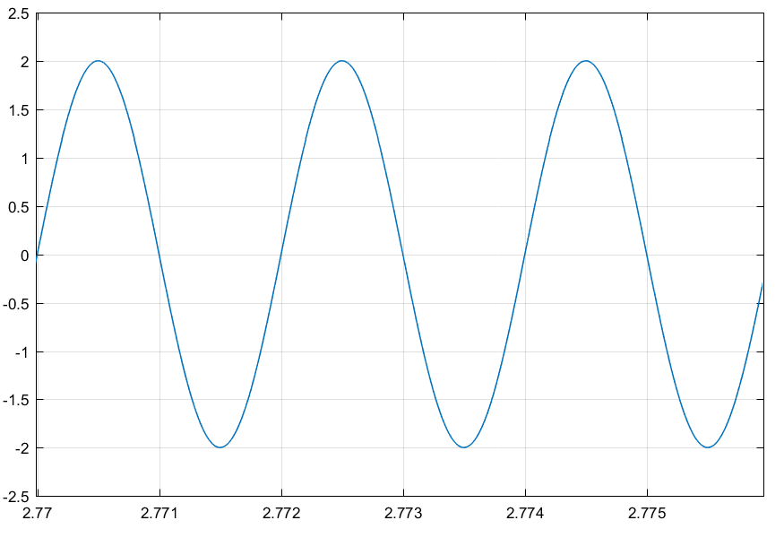

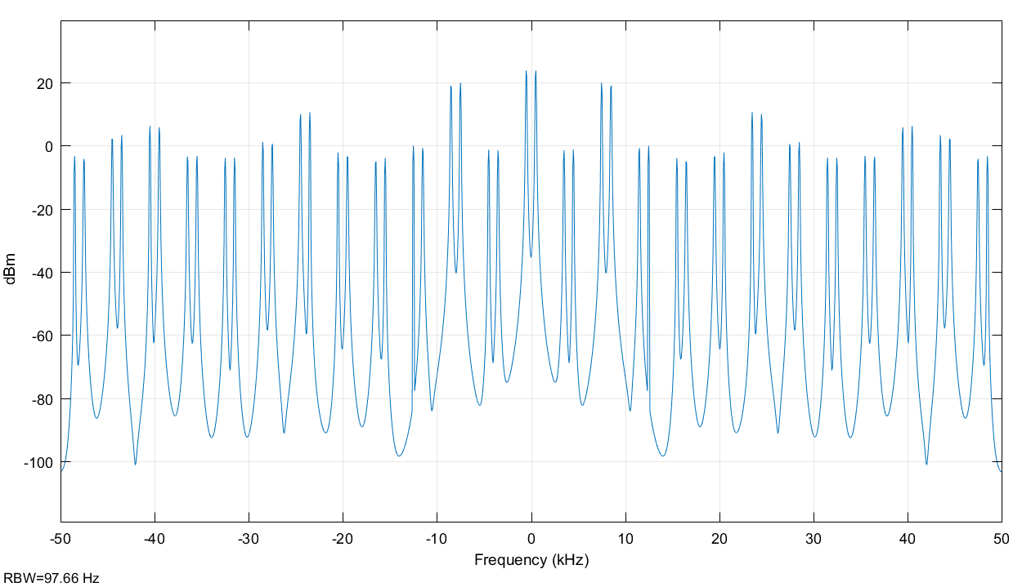

Input scope signal and the scope (S/H)

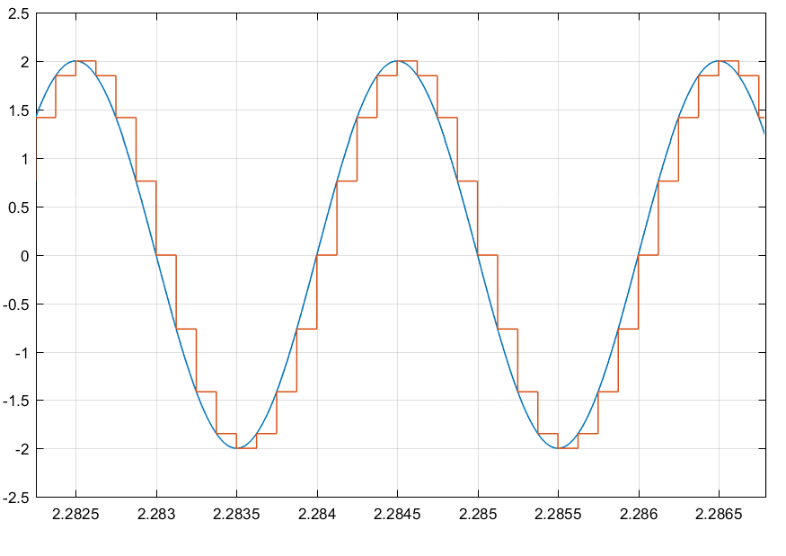

Q2.

Compare outputs, comment on the effect on the spectrum of the source signal when multiplying with a pulse train. Explain why the output of the analog lowpass filter is the recovered source signal.

Multiplies the bandwidth along the sine wave with the pulse signal, the bandwidth will be repeated every pulse function when it is high.

Spectrum Source

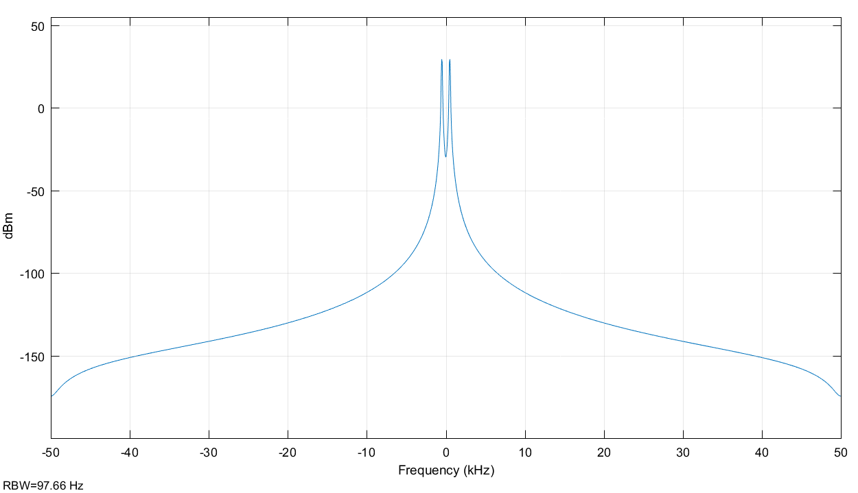

Spectrum (Sample)

Q3.

Comment on the number of quantization levels and quantization bits utilized.

Number of plateaux = levels

Bits, is log base 2(L)

Scope (ADC)

Blue: from Encoder (same as the Scope (ADC))

Orange: from sampling

Yellow: From Decoder

Codebook values: are the boundaries on the y-axis if -1.5:1.5 means from -1.5 to 1.5 so the range is 1.5-(-1.5) = 3 so we will have 3 levels +1 (ground level) -> same for when you change. Will see that it changes for the blue graph

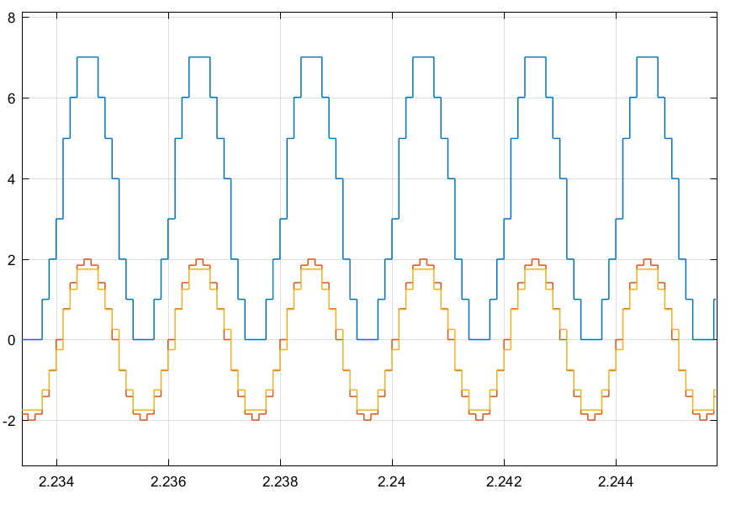

Same with different boundary points.

By changing the boundary points, the encoder has a different number of levels.

Due to the fact that the boundaries have changed

Scope (ADC)

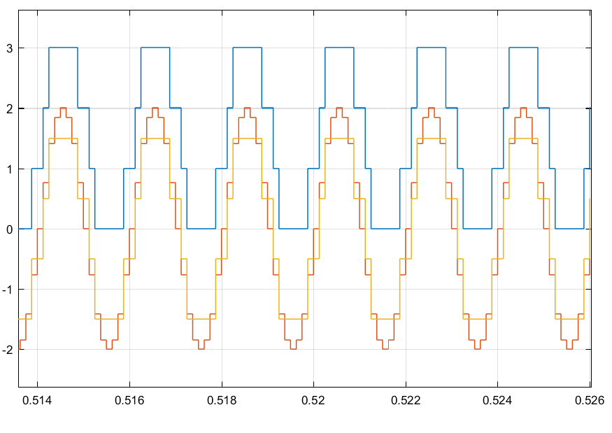

Scope (S/H) if needed

Observe that the Scope of (S/H) (sample)

Does not change when we change the codebook values

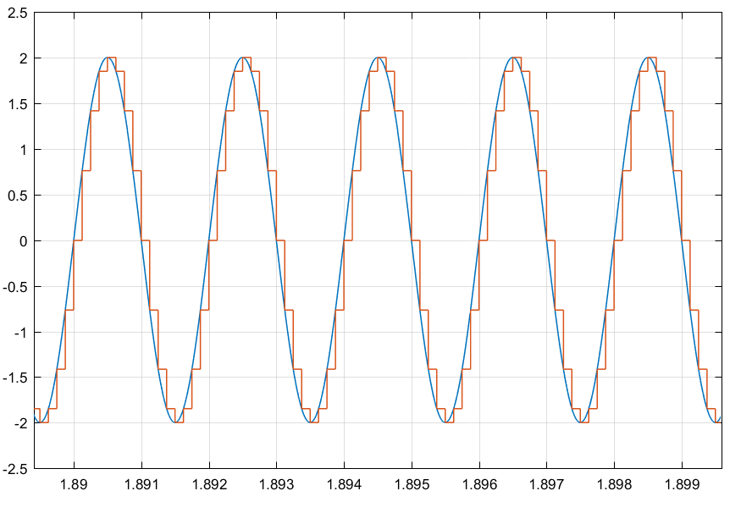

Part 1.2:

We use the bernoulli, 0 or 1, then with the constant and gain we change the range from -5 to 5.

Tx will then have a more samples per time.

Then we add noise,and we sample back to retrieve the initial data. We can see from (Rx) and (S/H) then with Rx there were more samples/time and it can be messy, whereas S/H actually have the “correct” in relationship to the initial input signal. Then (PAM) show the output signal which should be the same as the input signal, where some errors may not have been detected.

We can check it from the error rate calculator, and observe that for a high SNR the error will be small than a small SNR value.

|  |  |
| --- | --- |
| SNR | BER |
| 0 | 0.1624 |
| 2 | 0.1046 |
| 4 | 0.0533 |
| 6 | 0.0213 |
| 8 | 0.0053 |
| 10 | 0.0011 |

Part 2

ASK

Scope (mod)

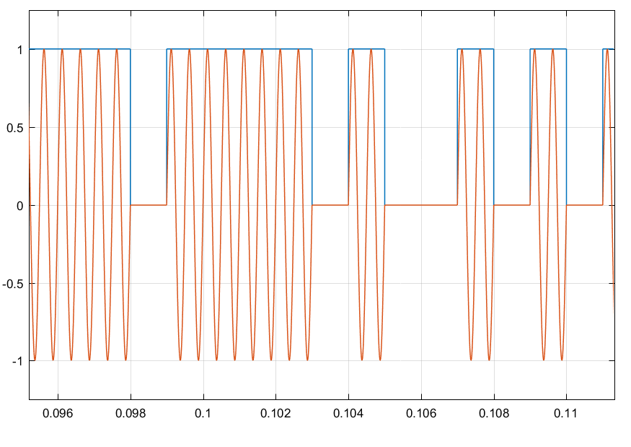

BPSK

scope(mod)

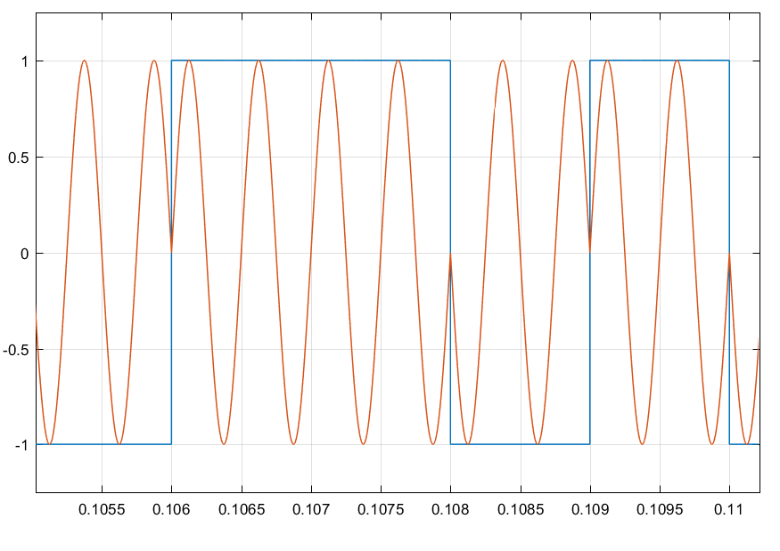

FSK

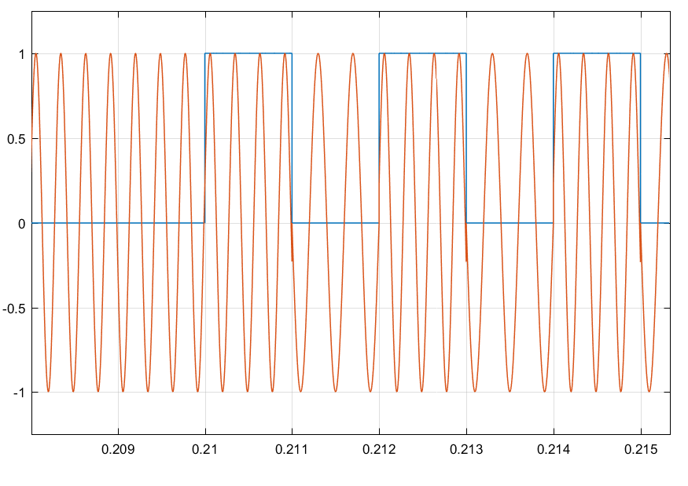

4-QAM

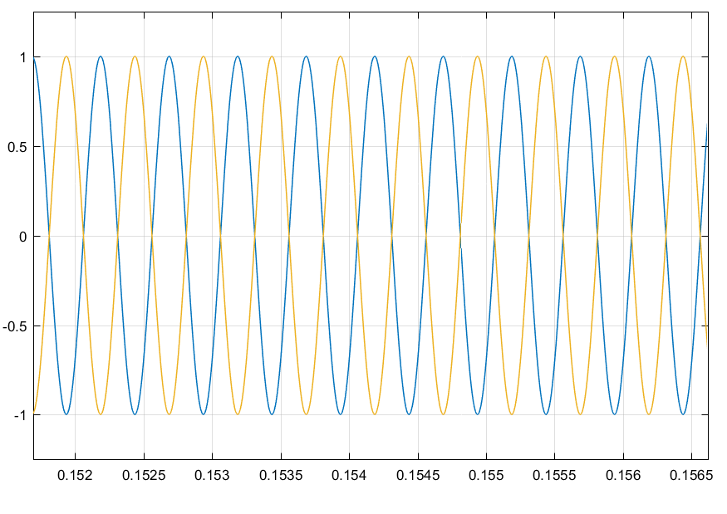

4 QAM is both PSK and amplitude modification, therefore from a binary PSK we can add onto it a change in amplitude to get a QAM.

Power spectrum of 4-QAM is related to that of binary PSK.

Part 3:

Find bandwidth spectrum from FStart: 0 to 500000

The value calculated is the value of the bandwidth (NO times 2)

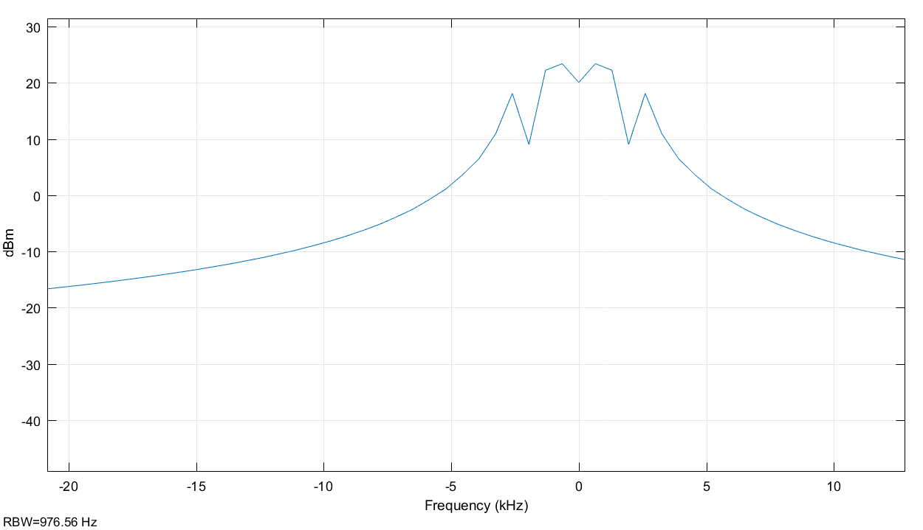

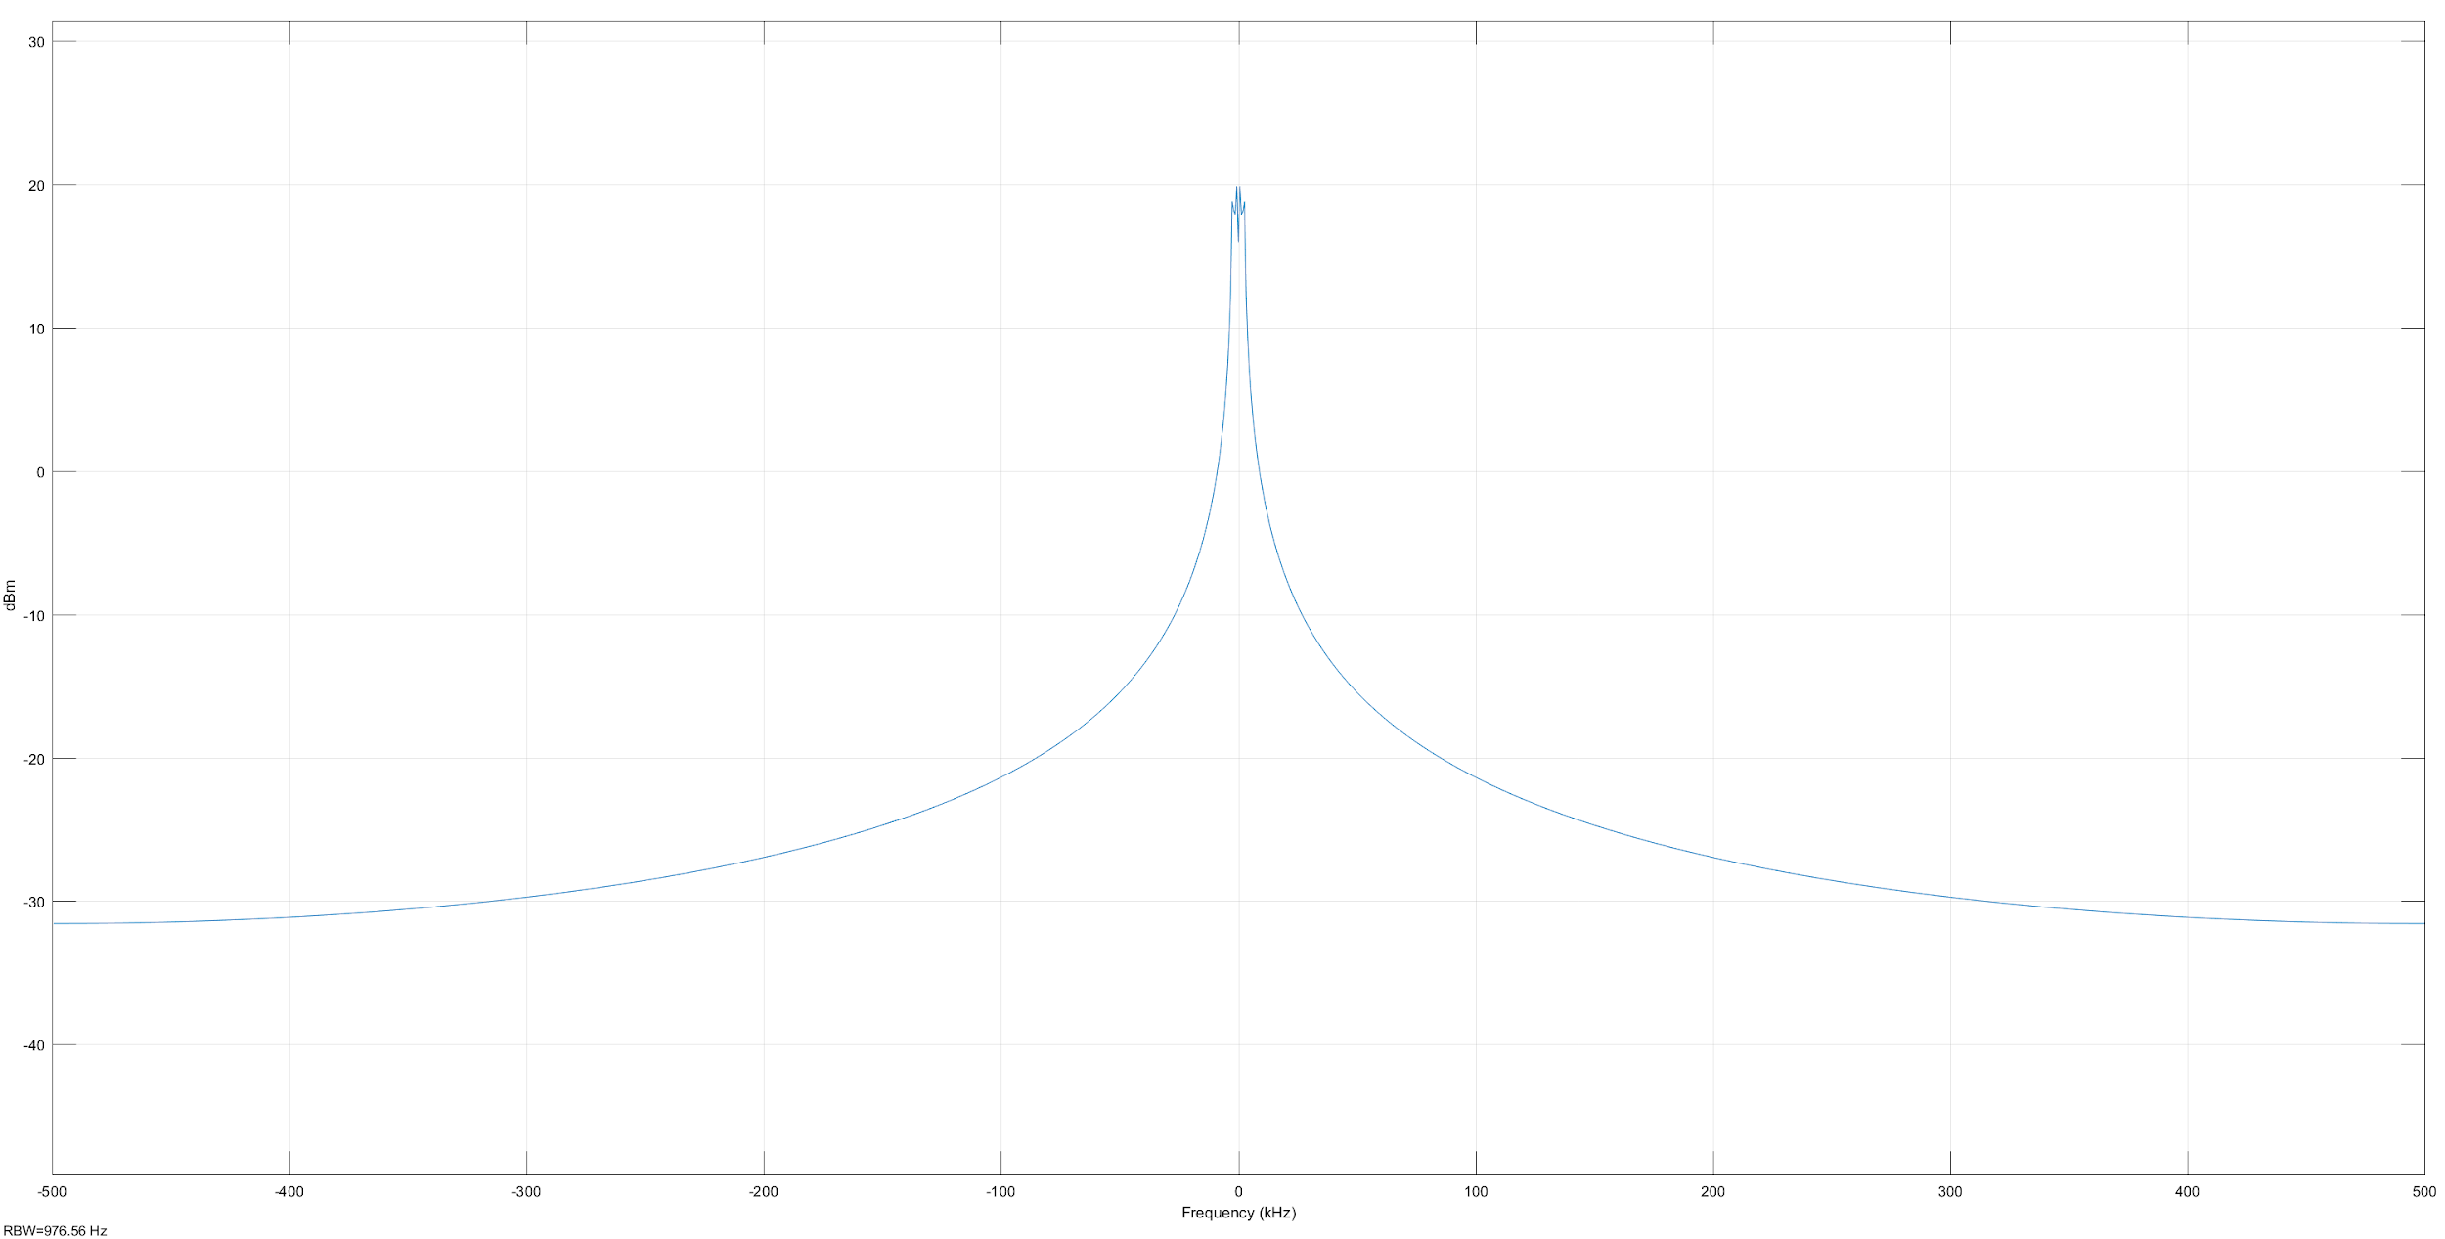

Bandwidth value of 22.5692

Taking over 1000 samples to have an average

4.

Bandwidth for 1 sample

Either 1 bandwidth, 1 sample, no noise

Or 2500 bandwidth, 2500 samples, and we have a constellation

How many bits a symbols carry 4 bits

Describe the mapping between bits and symbols.

2 levels of amplitude, and 2 levels of phases

3. Effect of Noise

Deviation from the exact point on the constellation, when noise increases the points are further from the point. When noise decreases, points are regrouped closer to the point.

4. As we increases SNR, constellation gets closer together

SNR is inverse to noise so it reacts inversely as noise

So SNR increases, BER decreases.

5. 5 dB to 20 dB

Plot BER vs Es/No

For smaller SNR -> higher Eb/No

BER increases as bandwidth increases

As Eb/No increases

|  |  |  |
| --- | --- | --- |
| Eb/No | BER |  |
| 5dB | 0.1624 |  |
| 10 | 0.01 |  |
| 12 | 0.0008 |  |
|  |  |  |
|  |  |  |
|  |  |  |